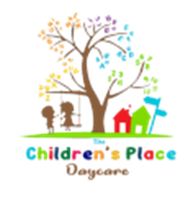

The Children’s Place Daycare

Enrollment

Registration Fee: $50.00 per child (non-refundable)

Weekly Tuition: $207.14 per child (6 weeks-18 months)
$189.40 per child (18 months-2 years)
$165.56 per child (ages 3, 4, and 5)
$125.00 per child (School age: full time summer)
$100.00 per child (School age: Before & After School)

Part-time Tuition: $120.00 per child (2-12 years)
$140.95 per child (infant-2 years)

Week Day Drop-In: $50.00 per child (3,4, and 5 years)
$60.00 per child (infant – 2 Years)

